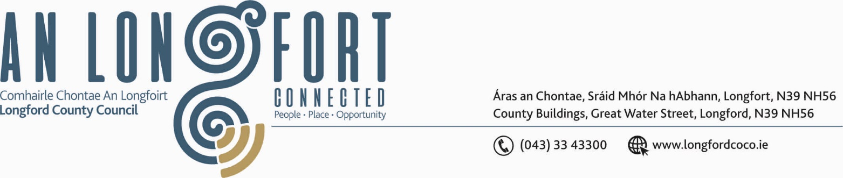

BALLYMAHON MUNICIPAL DISTRICT

Please Note Venue of Meeting - Ballymahon Community Library

16th October 2020.

To: Each Member of Ballymahon Municipal District.

A Chomhairleoir,

You are requested to attend the following Ballymahon Municipal District Meeting on Thursday, 29th October 2020 in Ballymahon Community Library to transact business, as set out on the Agenda hereunder-

- Municipal District Meeting at 4.00 p.m.

Mise le meas,
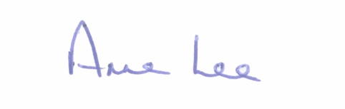

________________
Anne Lee,
Meetings Administrator.

AGENDA

Prayer before meeting.

1. 2021 General Municipal Allocation.

